**NOT GATE**

**The output is the inverse of the input.**

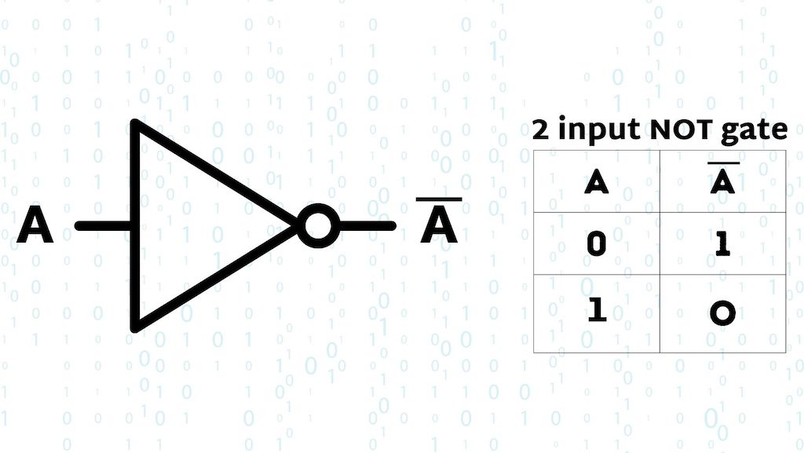

$$A= \overline{A}$$

|  |  |
| --- | --- |
| **A** | $$\overline{A}$$ |
| **0** | **1** |
| **1** | **0** |